COURSE- Data Structure and Algorithms
NAME -Khushi Ramolia
ROLL NO. - 25MCE009
MTech CSE

EXPERIMENT 2

Implement iterative and full recursive versions of the following sorting techniques and repeat the experiment for larger values of n with different input patterns, and plot the comparison graph of a number of elements versus execution time taken. The elements can be read from a file or can be generated using a random number generator.
For Merge sort and External Merge Sort .

MERGE SORT -

Code
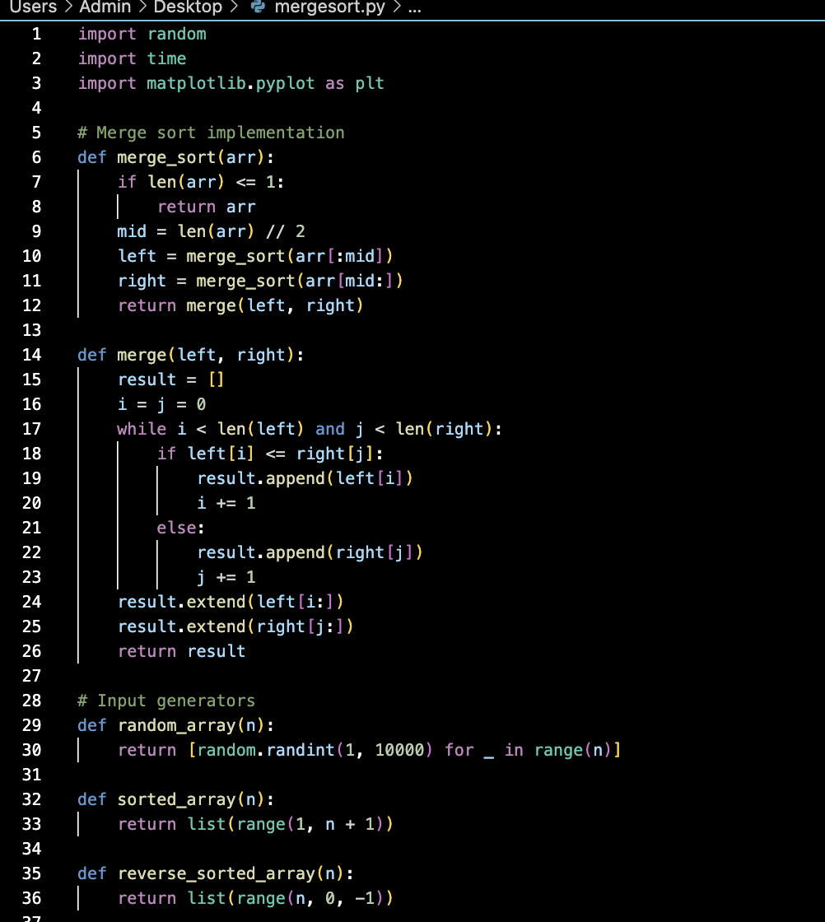
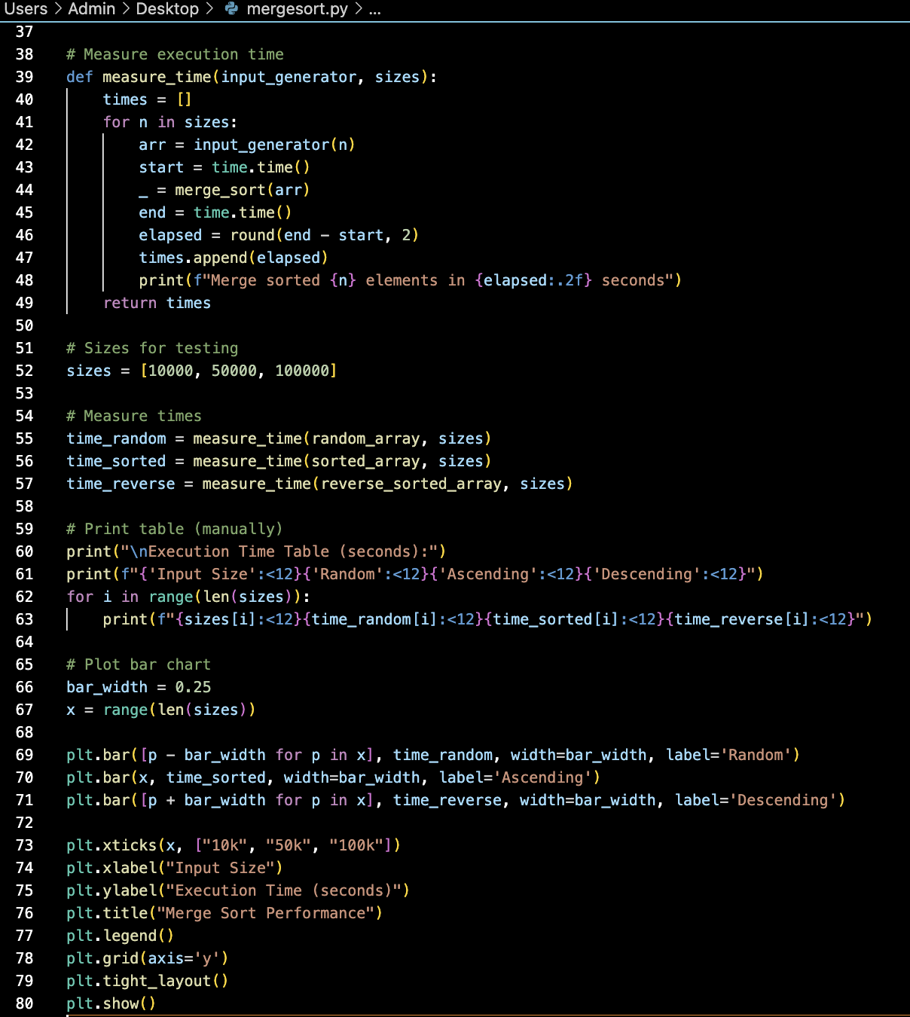

OUTPUT-
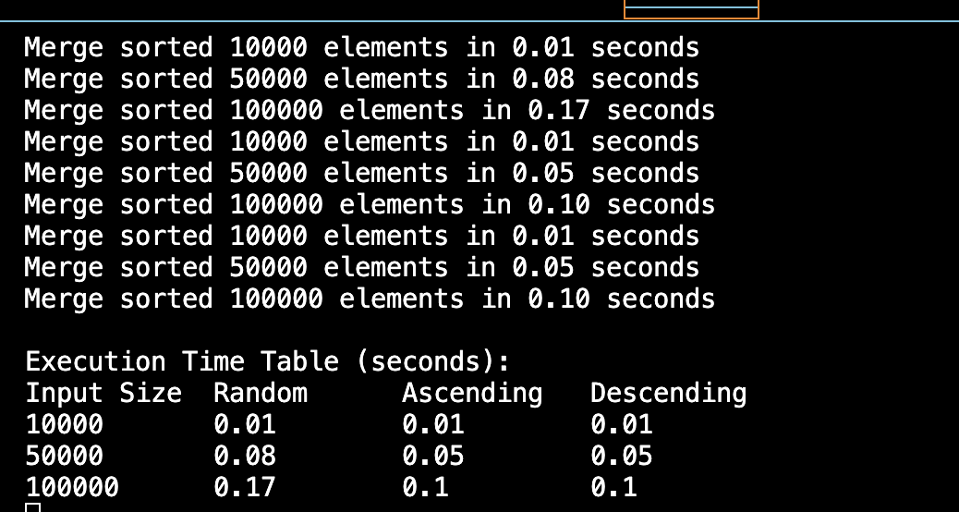

GRAPH-

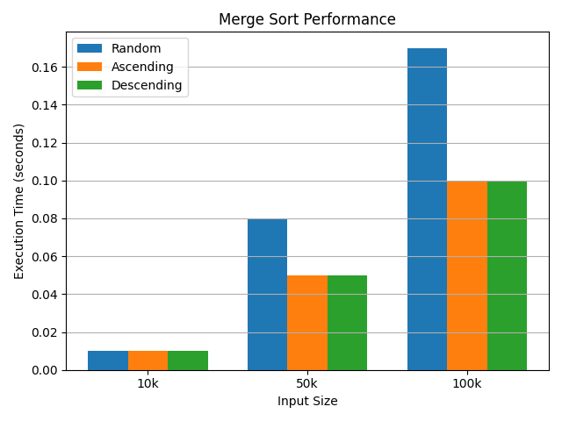

GRAPH ANALYSIS-
The bar chart shows three distinct groups (10k,50k,100k)
Within each group-
Random input bars are taller —> slower execution
Ascending and Descending bars overlap,showing equal efficiency

OVERALL ANALYSIS -
Execution time increases as input size grows from 10k → 100k, showing the expected O(nlogn) behavior of Merge Sort, that is it breaks down the problem into smaller pieces quickly and then it combines everything back quickly.

Best Case (Sorted/Descending Input):
- Surprisingly, sorted (ascending) and reverse sorted (descending) inputs perform slightly better than random inputs.
- This happened because the merging process has fewer comparisons in structured data.
Worst Case (Random Input):
- Random input consistently takes the longest time, especially visible at 100k (0.17s vs 0.10s).
- Still, the difference is not very large, which proves Merge Sort is relatively input-independent compared to Quick Sort.

EXTERNAL MERGE SORT -
Code-

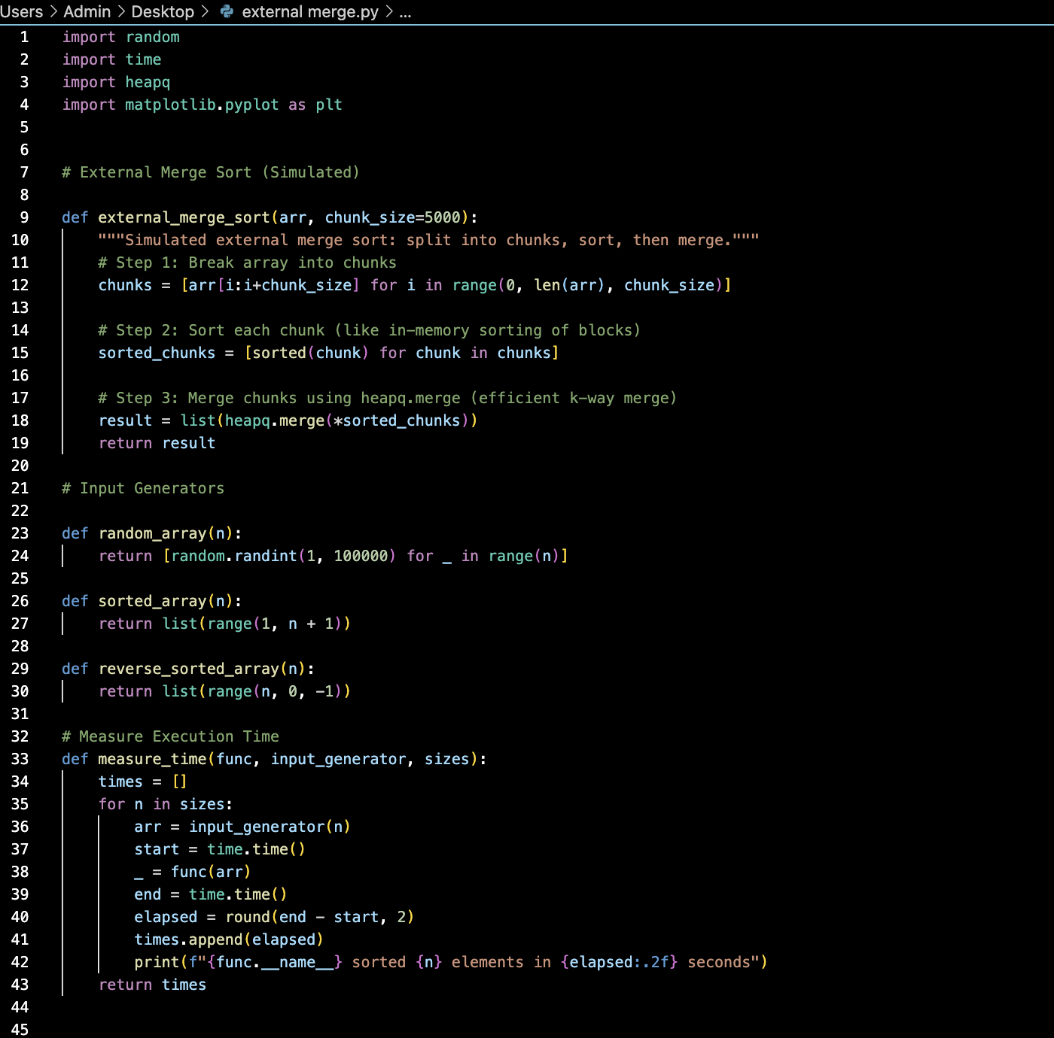
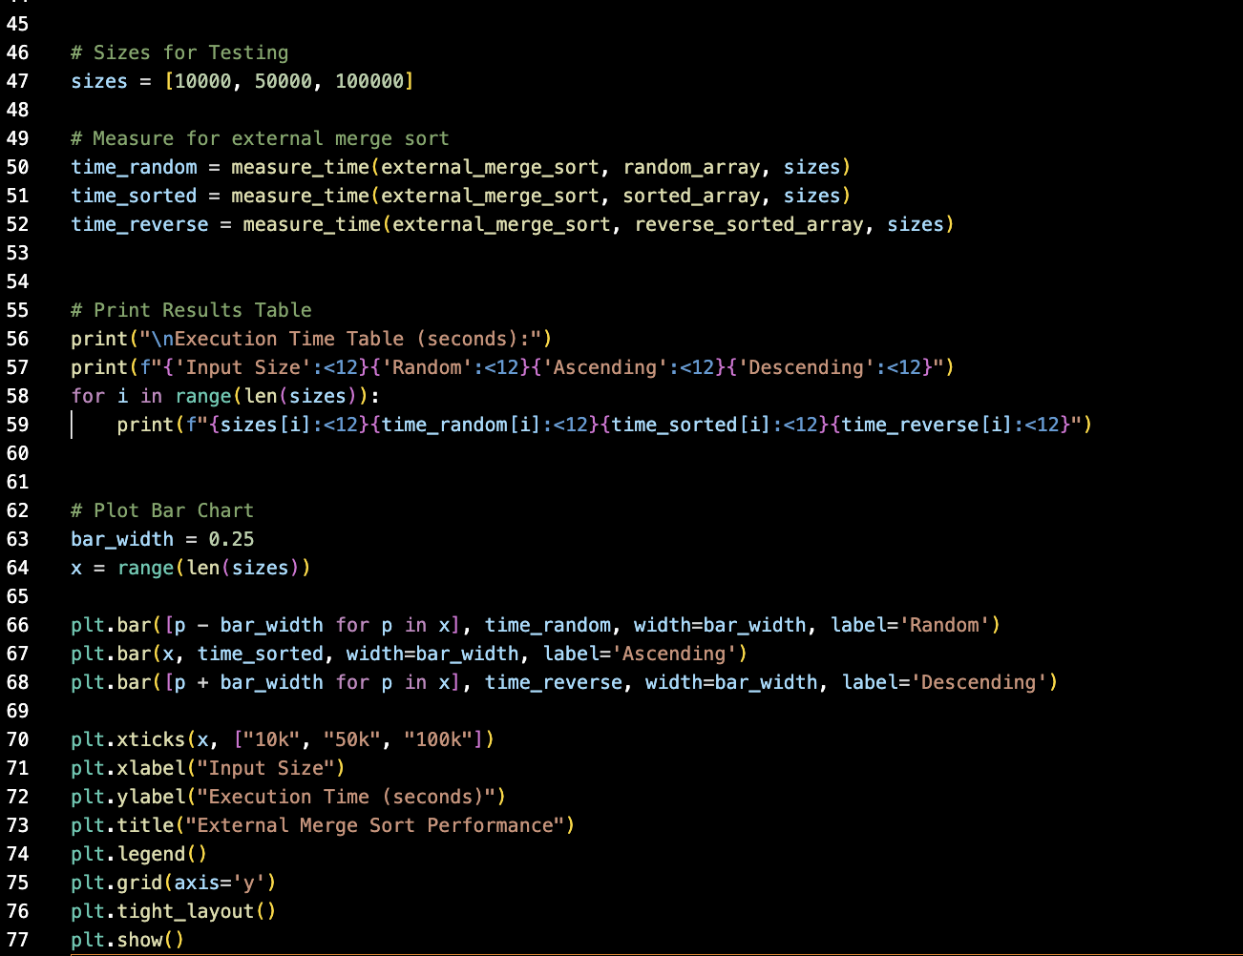

OUTPUT-
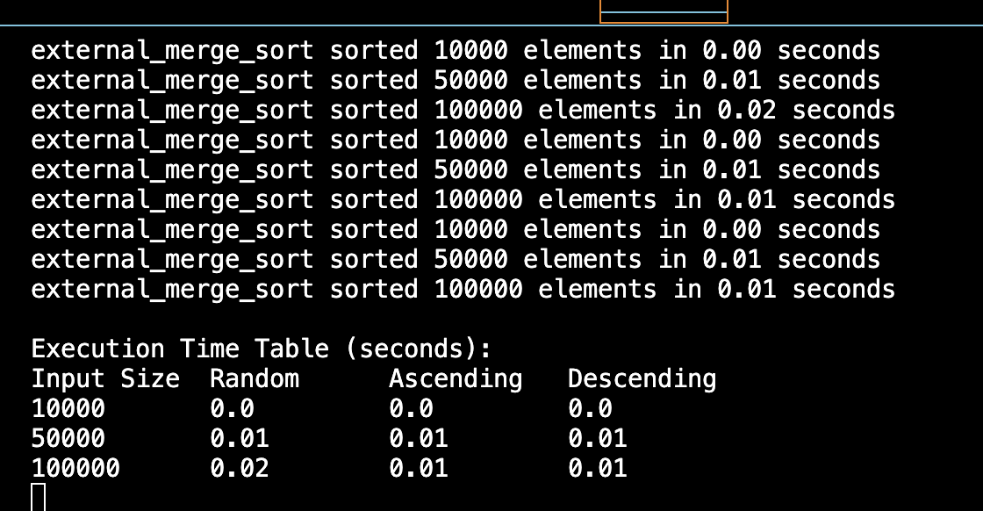

GRAPH-
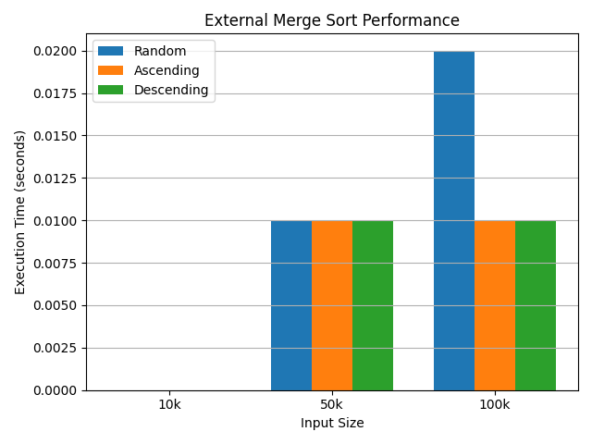

Graph Analysis – External Merge Sort
- Three groups are visible (10k, 50k, 100k elements).
  - Each group represents different input sizes.
  - As we move from 10k → 50k → 100k, bar heights increase, showing execution time grows with input size.
- Random input bars are the tallest in each group -This indicates random data takes more time to merge because comparisons are maximum.
- Ascending and Descending input bars overlap -Both are almost equal in height.This means External Merge Sort works equally efficiently on sorted and reverse-sorted data.
- Overall trend:
  - All bars increase gradually with input size.
  - Confirms the O(n log n) growth pattern of External Merge Sort.

Overall all Analysis
- Small Inputs (10k elements):
  - Time taken is almost negligible (0.0 sec).
  - This is because the dataset is small enough to handle quickly.
- Medium Inputs (50k elements):
  - Execution time increases slightly (~0.01 sec).
  - Very little difference across random, ascending, or descending inputs.
- Large Inputs (100k elements):
  - Execution time grows more (~0.02 sec for random, 0.01 sec for structured inputs).
  - Still efficient and predictable.
- Random Input: Takes the most time (0.02 sec for 100k).
- Ascending / Descending Input: Both take less time (0.01 sec).
  - This happens because structured data requires fewer comparisons during merging, so the algorithm finishes faster.

